**Officer Intelligence Rating - 6**

1. Give the choice providing the best answer in the following statement :

Each nation must maintain an army because

1. it makes people strong.
2. it ensures work to a sizable section of population.
3. it is indispensable for the defense of nation
4. it can help in the expansion of territory
5. Supply the missing number

8, 80, 7, 70, 6, 60, 5, ?

1. 55
2. 45
3. 50
4. 40
5. Which pair is different from the others in the following?
6. Student and School
7. Canteen the garden
8. Book and library
9. Ink and pen.
10. Which letters will you put in place of the question mark?

NZ OY PX QW RV ?

1. FS
2. SU
3. UF
4. ST
5. Insert the missing number

437 410 642

541 ? 783

1. 480
2. 400
3. 302
4. 484
5. Find the odd man out :
6. STUN
7. PAGRE
8. MUPL
9. SNUG
10. Insert the missing words:

SING (NINE) SPEND

LONG (…….) CREST

1. PINE
2. FINE
3. NOSE
4. SOLE
5. Which number will come in place of the question mark in the following?

2 10 4

3 17 5

3 ? 4

1. 11
2. 12
3. 13
4. 14
5. Spot the odd man out in the following ?
6. Hindustan
7. Statesman
8. Indian Express
9. Dharam Yug
10. Select the appropriate word to fill in the blank space out of the choice given below :

HANDSOME is to BEAUTIFUL as …….. is to SHE

1. Lovely
2. Charming
3. Man
4. He
5. There are four roads. I have come from the South and want to go the temple. The road to the right leads me away from the coffee house; straight ahead it leads only to a college. In which direction is the temple?
6. North
7. South
8. East
9. West
10. Which number will come in place of the question mark in the following?

12 + 9 = 1084

11 + 8 = 884

14 + 7 = 984

15 + 6 = ?

1. 928
2. 904
3. 1088
4. 988
5. Which of the following does not belong to the category of others?
6. 625
7. 361
8. 256
9. 197
10. A friend of mine came to meet me every Sunday. The first time he came at 12 : 30, the next time at 1 : 20, then at 2 : 30, then at 4 : 00, when did he turn up the time after that?
11. 5 : 20
12. 5 : 30
13. 6 : 20
14. 5 : 50
15. Which is odd man out in the following?
16. Shelley
17. Keats
18. Chaucer
19. Churchill
20. Which number will come in place of the question mark in the following?

15 13 12 11 9 9 ?

1. 8
2. 7
3. 6
4. 10
5. There are 10 crows sitting on a branch. One is shot at with a gun and is killed. How many remain thereafter?
6. 3
7. 2
8. 5
9. 0
10. Pick out the word from choices given below which goes with the three at the top :

FOOT LAW BED

1. table
2. tower
3. judge
4. free
5. What continues the series

66 77 88 99 ?

1. 100
2. 110
3. 120
4. 150
5. A school requires girls to wear a pale green skirt and blouse or a pale green saree and blouse. 30 of fifty girls in a class wear skirts. Girls have to opt either for Guilding or Social service. Those opting for Social Service have to wear sarees. Therefore which of the following statement is definitely true?
6. 20 girls have opted for Social Service
7. 30 girls have opted for Guilding
8. At least 30 girls have opted for Guilding
9. At least 20 girls have opted for Social Service.
10. SUCCESS is related to HARD WORK as FAILURE is to
11. industry
12. diligence
13. waste of time
14. laziness
15. What continues the series ?

10, 5, 9, 5, 8, 5, ?

1. 6
2. 7
3. 9
4. 11
5. If the word BANGALORE is written as CBOHBMPSF in a code, how is CHANDIGARH written in that code?
6. DEBOEFHBSJ
7. DIBOEJHBSI
8. HRAGIDNAHC
9. DIGBSHOBIB
10. ‘GRAS’ and ‘LECTTUCE’ bear same relationship; which of the following bear that relationship?
11. onion : flower
12. truck : station wat
13. farm : garden
14. snow : milk
15. Find the missing number in the series :

8, 4, 12, 6, 18, 9 ?

1. 26
2. 27
3. 28
4. 30
5. If 7M = 3M – 20, then M + 7 is equal to
6. – 1
7. 0
8. +1
9. 2
10. Which choice answer the question :

If 5 $×$ 8 = 20 $6 ×9=27$

$8 ×12=48$ $4 ×6=$ 12

$then 9 ×16= ?$

1. 63
2. 72
3. 80
4. 96
5. If the following names were arranged as in the dictionary, which would be third?
6. Shantar
7. Shyam
8. Shanker
9. Shambhu
10. Insert the missing letter –

V S L O H ?

1. G
2. I
3. F
4. E
5. Three of the following are alike in some way. Which one is not like the other four?
6. Blue
7. White
8. Red
9. Table

**Directions : In these questions, there are five figures. Four of these are similar in a certain way, but one is not like the others. You have to find which one of the figures is different from the other four.**

1. Problem Figures

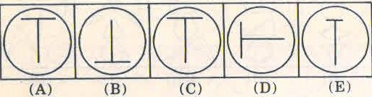

1. Problem Figures

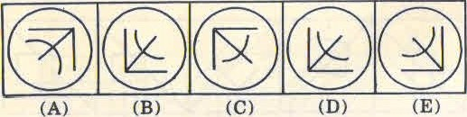

1. Problem Figures

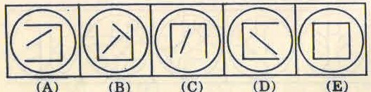

1. Problem Figures

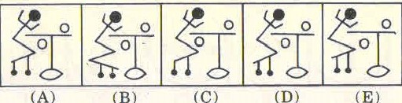

1. Problem Figures

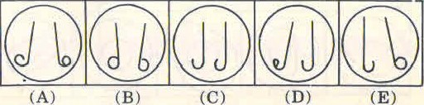

1. Problem Figures

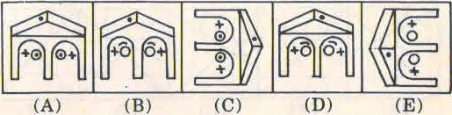

1. Problem Figures

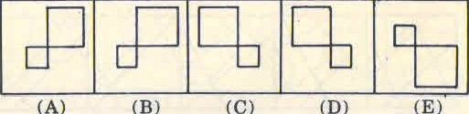

1. Problem Figures

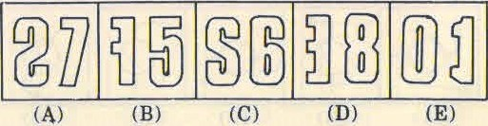

1. Problem Figures

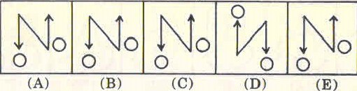

1. Problem Figures

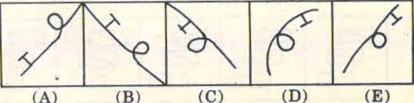

**Directions : In these questions, there are two sets of figures. One is ‘Problem Figures’, while the other is ‘Answer Figures’. The Problem Figures make a series. Find out which one of the Answer Figures would occupy the fifth position in the problem Figures, if they continue to change in the same order.**

1. 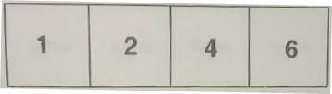
2. 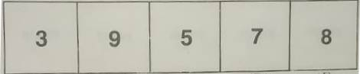
3. 
4. 

**10**

1. 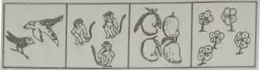
2. 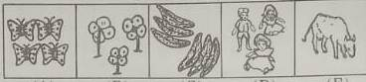
3. 
4. 
5. 
6. 
7. 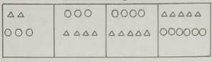
8. 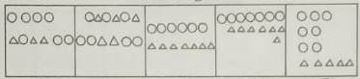
9. 
10. 
11. 
12. 
13. 
14. 
15. 
16. 
17. 
18. 
19. 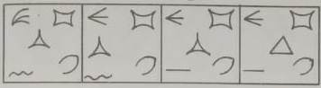
20. 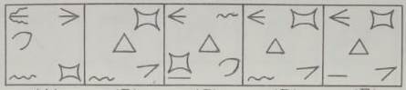
21. 
22. 
23. 
24. 
25. 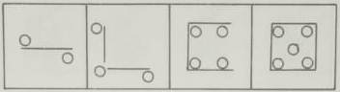
26. 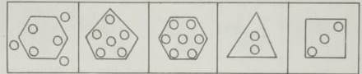
27. 
28. 
29. 
30. 
31. 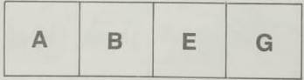
32. 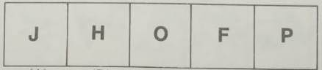
33. 
34. 
35. 
36. 
37. 
38. 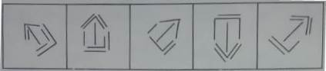
39. 
40. 
41. 
42. 
43. 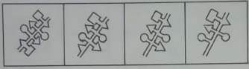
44. 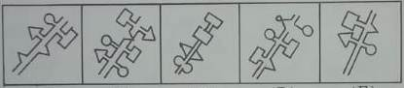
45. 
46. 
47. 
48. 
49. 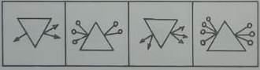
50. 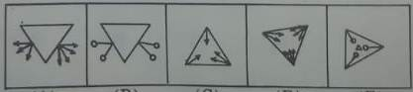
51. 
52. 
53. 
54. 

ANSWERS

|  |  |  |  |  |  |  |  |  |  |
| --- | --- | --- | --- | --- | --- | --- | --- | --- | --- |
| 1. **C** | 1. **C** | 1. **A** | 1. **E** | 1. **A** | 1. **A** | 1. **B** | 1. **E** | 1. **D** | 1. **B** |
| 1. **C** | 1. **B** | 1. **A** | 1. **C** | 1. **A** | 1. **B** | 1. **A** | 1. **A** | 1. **C** | 1. **B** |
| 1. **D** | 1. **B** | 1. **A** | 1. **D** | 1. **B** | 1. **B** | 1. **D** | 1. **C** | 1. **C** | 1. **D** |
| 1. **D** | 1. **C** | 1. **C** | 1. **D** | 1. **D** | 1. **D** | 1. **A** | 1. **B** | 1. **A** | 1. **C** |
| 1. **D** | 1. **B** | 1. **C** | 1. **C** | 1. **B** | 1. **B** | 1. **B** | 1. **A** | 1. **D** | 1. **C** |