1. ORANGE is coded as ‘LOXKDB’ then GRAPES is coded as?
2. DOYMBP
3. DOXNBP
4. DOXMBP
5. DPXMBP
6. DOXMBQ
7. MONEY is coded as ‘Innpmodfxz’, then RUPEE is coded as?
8. Qstvoqdfdf
9. Qsvtoqdtdf
10. Qstvqodfdf
11. Qstvoqtdfd
12. ‘NIGRE’ is coded as ‘ADOQC’ then ‘ENGINEER’ is coded as?
13. CAODCACQ
14. CADOACCQ
15. CAODACQC
16. CODACACQ
17. CAODACCQ
18. ‘LEAVE HIM’ is coded as ‘JCYTC FGK’, ‘CATCH URGENTLY’ is coded as?
19. AXRYG SPECLRJW
20. AYRAF SPECLRJW
21. AXRYF SPECMRJW
22. AYRAF SRDCLPJW
23. AYRAG SPDCLRJW
24. ‘DANCE’ is coded as ‘12345’ and ‘DANGER’ is coded as ‘EAGERED’ is coded as?
25. 5465751
26. 5275651
27. 5365751
28. 5265751
29. 5635751
30. A man walks 7 km towards south, then turns $60°$ and walks 15 km, then turns right and walks 12 km, then turns right and walks 15km, then turns left and walks 5 km. Then find the direction he is from the starting point ?
31. South – East
32. South
33. East
34. North
35. West
36. A girl walks 25 meters towards east, then turns right walks 45 meters and turns right and walks 25 meters right and turns right and walks 78 meters. Then find the distance she has walked from the starting point and find the direction she is from the starting point ?
37. 33 m, south
38. 33 m, north
39. 45 m north
40. 25 m, north
41. 78 mm north
42. A person walks 7 km towards south and turns right, walks 3 km and turns left, walks 13 km and then turns left, walks 3 km and turns right, walk 4 km and turns left, walks 4 km and then turns right, walks 6 Km and turns right, walks 4 km. Find in which direction he is from the starting point and the distance he is from the starting point.
43. South, 23 km
44. East, 23 Km
45. South, 30 Km
46. North, 23 Km
47. North, 30 Km
48. A man walks 4 kms towards north and turns right, walks 7 kms and turns right, walks 4 kms and turns left, walks 9 kms, turns left and walks 4 kms then turns right, walks 6 kms and turns right and walks 4 kms. Find the distance he is from the starting point and in which direction is he from the starting point?
49. 20 Km, west
50. 22 km, east
51. 32 km, south
52. 22 km, south
53. 22 km, north
54. A man walk 10 kms towards east, then turn 600 angle left, walks 6 kms and turns right, walks 5 km and turns 300 angle right and walks 4 kms. Then find in which direction he from the starting point?
55. North-east
56. North-west
57. South-east
58. South-west
59. North

**Direction (Q.Nos. 11- 20) in the following questions select the figure from the choices which comes next in the series**

1. 
2. 
3. 
4. 
5. 
6. 
7. 
8. 
9. 
10. 
11. 
12. 
13. 
14. 
15. 
16. 
17. 
18. 
19. 
20. 
21. 
22. 
23. 
24. 
25. 
26. 
27. 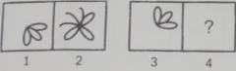
28. 
29. 
30. 
31. 
32. 
33. 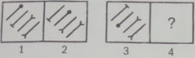
34. 
35. 
36. 
37. 
38. 
39. 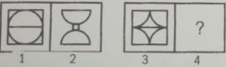
40. 
41. 
42. 
43. 
44. 
45. 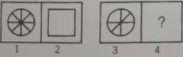
46. 
47. 
48. 
49. 
50. 
51. 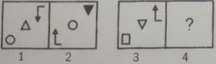
52. 
53. 
54. 
55. 
56. 
57. How many squares are there in the following figure?

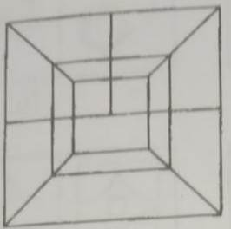

1. 5
2. 9
3. 7
4. 8
5. None of these
6. How many squares are there in the following figure?

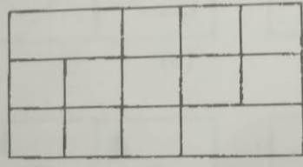

1. 10
2. 16
3. 14
4. 12
5. None of these
6. How many triangles are there in the following figure?

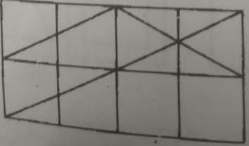

1. 29
2. 23
3. 19
4. 21
5. None of these
6. How many triangles are there in the following?

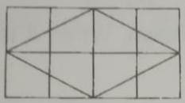

1. 22
2. 18
3. 8
4. 16
5. None of these
6. How many rectangles are there in the following figure?

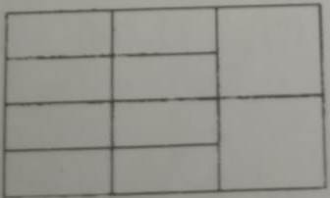

1. 10
2. 13
3. 8
4. 16
5. None of these
6. What will be the number at the bottom if 5 is at the top? The two positions of the dice are being given below?

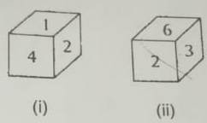

1. 3
2. 4
3. 2
4. 6
5. None of these
6. A dice is thrown four times and its four different positions are given below. Find the number on the face opposite the face showing 2.

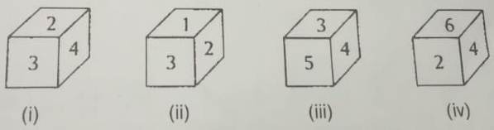

1. 3
2. 4
3. 5
4. 6
5. None of these
6. Two positions of a dice are shown. When 4 is at the bottom, what number will be on the top?

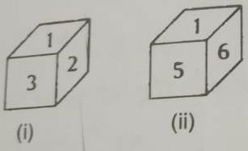

1. 1
2. 2
3. 5
4. 6
5. None of these
6. 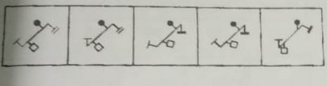
7. 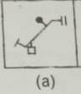
8. 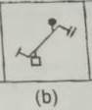
9. 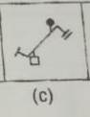
10. 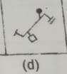
11. 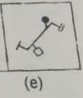
12. 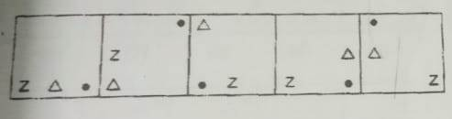
13. 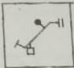
14. 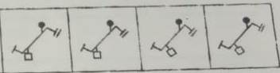
15. 
16. 
17. 
18. 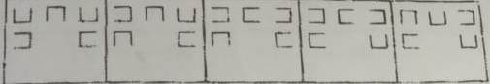
19. 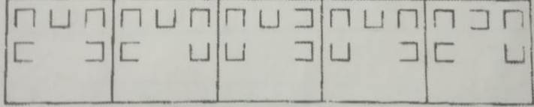
20. 
21. 
22. 
23. 
24. 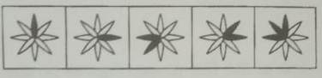
25. 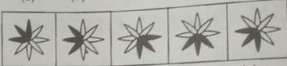
26. 
27. 
28. 
29. 
30. 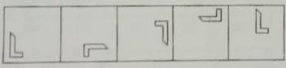
31. 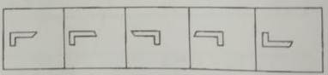
32. 
33. 
34. 
35. 
36. 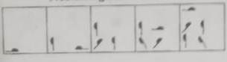
37. 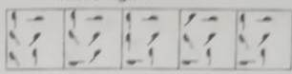
38. 
39. 
40. 
41. 
42. 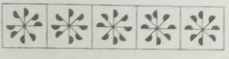
43. 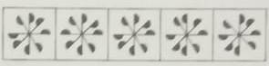
44. 
45. 
46. 
47. 
48. 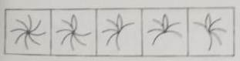
49. 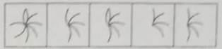
50. 
51. 
52. 
53. 
54. 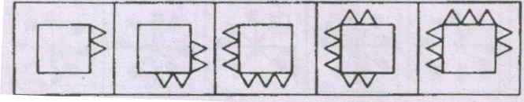
55. 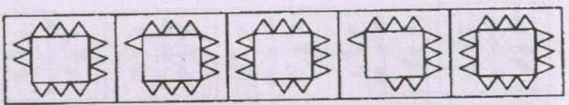
56. 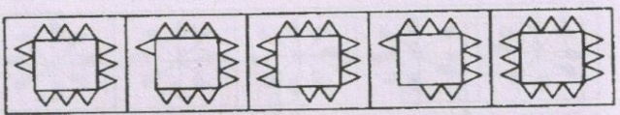
57. 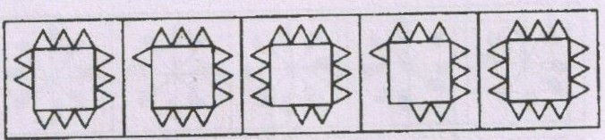
58. 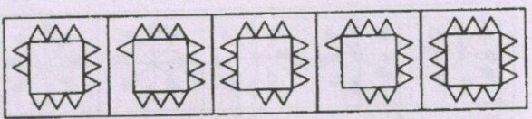
59. 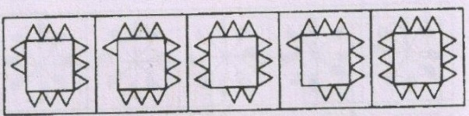
60. 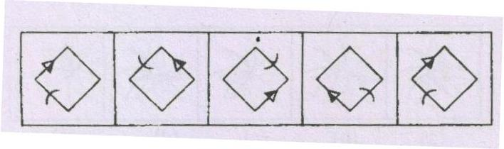
61. C:\Users\pc\AppData\Local\Microsoft\Windows\Temporary Internet Files\Content.Word\616f7650-d415-4bfe-b255-63e575068ea3.jpg
62. C:\Users\pc\AppData\Local\Microsoft\Windows\Temporary Internet Files\Content.Word\616f7650-d415-4bfe-b255-63e575068ea3.jpg
63. C:\Users\pc\AppData\Local\Microsoft\Windows\Temporary Internet Files\Content.Word\616f7650-d415-4bfe-b255-63e575068ea3.jpg
64. C:\Users\pc\AppData\Local\Microsoft\Windows\Temporary Internet Files\Content.Word\616f7650-d415-4bfe-b255-63e575068ea3.jpg
65. C:\Users\pc\AppData\Local\Microsoft\Windows\Temporary Internet Files\Content.Word\616f7650-d415-4bfe-b255-63e575068ea3.jpg
66. C:\Users\pc\AppData\Local\Microsoft\Windows\Temporary Internet Files\Content.Word\b47aa895-314d-4c01-9be9-b00aa40eb011.jpg
67. C:\Users\pc\AppData\Local\Microsoft\Windows\Temporary Internet Files\Content.Word\b47aa895-314d-4c01-9be9-b00aa40eb011.jpg
68. C:\Users\pc\AppData\Local\Microsoft\Windows\Temporary Internet Files\Content.Word\b47aa895-314d-4c01-9be9-b00aa40eb011.jpg
69. C:\Users\pc\AppData\Local\Microsoft\Windows\Temporary Internet Files\Content.Word\b47aa895-314d-4c01-9be9-b00aa40eb011.jpg
70. C:\Users\pc\AppData\Local\Microsoft\Windows\Temporary Internet Files\Content.Word\b47aa895-314d-4c01-9be9-b00aa40eb011.jpg
71. C:\Users\pc\AppData\Local\Microsoft\Windows\Temporary Internet Files\Content.Word\b47aa895-314d-4c01-9be9-b00aa40eb011.jpg
72. 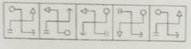
73. 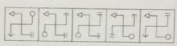
74. 
75. 
76. 
77. 
78. C:\Users\pc\AppData\Local\Microsoft\Windows\Temporary Internet Files\Content.Word\23c91e5c-7c66-4050-a37e-8f84794fb4e0.jpg
79. 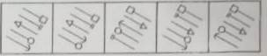
80. 
81. 
82. 
83. 
84. 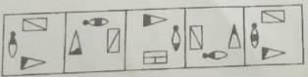
85. 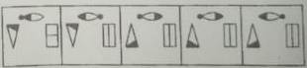
86. 
87. 
88. 
89. 
90. 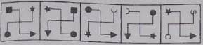
91. 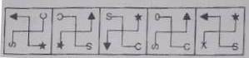
92. 
93. 
94. 
95. 
96. 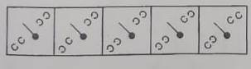
97. 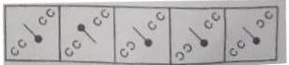
98. 
99. 
100. 
101. 
102. C:\Users\pc\AppData\Local\Microsoft\Windows\Temporary Internet Files\Content.Word\9d534cdd-62e7-44e2-b579-65d137007e50.jpg
103. C:\Users\pc\AppData\Local\Microsoft\Windows\Temporary Internet Files\Content.Word\9d534cdd-62e7-44e2-b579-65d137007e50.jpg
104. C:\Users\pc\AppData\Local\Microsoft\Windows\Temporary Internet Files\Content.Word\9d534cdd-62e7-44e2-b579-65d137007e50.jpg
105. C:\Users\pc\AppData\Local\Microsoft\Windows\Temporary Internet Files\Content.Word\9d534cdd-62e7-44e2-b579-65d137007e50.jpg
106. C:\Users\pc\AppData\Local\Microsoft\Windows\Temporary Internet Files\Content.Word\9d534cdd-62e7-44e2-b579-65d137007e50.jpg
107. C:\Users\pc\AppData\Local\Microsoft\Windows\Temporary Internet Files\Content.Word\9d534cdd-62e7-44e2-b579-65d137007e50.jpg
108. C:\Users\pc\AppData\Local\Microsoft\Windows\Temporary Internet Files\Content.Word\9d534cdd-62e7-44e2-b579-65d137007e50.jpg
109. C:\Users\pc\AppData\Local\Microsoft\Windows\Temporary Internet Files\Content.Word\9d534cdd-62e7-44e2-b579-65d137007e50.jpg
110. C:\Users\pc\AppData\Local\Microsoft\Windows\Temporary Internet Files\Content.Word\9d534cdd-62e7-44e2-b579-65d137007e50.jpg
111. C:\Users\pc\AppData\Local\Microsoft\Windows\Temporary Internet Files\Content.Word\9d534cdd-62e7-44e2-b579-65d137007e50.jpg
112. C:\Users\pc\AppData\Local\Microsoft\Windows\Temporary Internet Files\Content.Word\9d534cdd-62e7-44e2-b579-65d137007e50.jpg
113. C:\Users\pc\AppData\Local\Microsoft\Windows\Temporary Internet Files\Content.Word\9d534cdd-62e7-44e2-b579-65d137007e50.jpg
114. 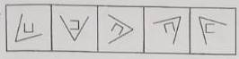
115. C:\Users\pc\AppData\Local\Microsoft\Windows\Temporary Internet Files\Content.Word\d93205d9-d8b1-49a0-9c39-484da0374622.jpg
116. C:\Users\pc\AppData\Local\Microsoft\Windows\Temporary Internet Files\Content.Word\d93205d9-d8b1-49a0-9c39-484da0374622.jpg
117. C:\Users\pc\AppData\Local\Microsoft\Windows\Temporary Internet Files\Content.Word\d93205d9-d8b1-49a0-9c39-484da0374622.jpg
118. C:\Users\pc\AppData\Local\Microsoft\Windows\Temporary Internet Files\Content.Word\d93205d9-d8b1-49a0-9c39-484da0374622.jpg
119. C:\Users\pc\AppData\Local\Microsoft\Windows\Temporary Internet Files\Content.Word\d93205d9-d8b1-49a0-9c39-484da0374622.jpg
120. 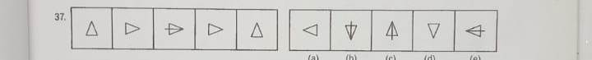
121. 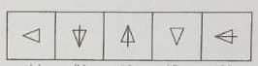
122. 
123. 
124. 
125. 
126. 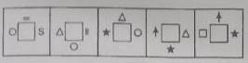
127. 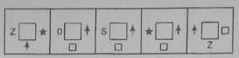
128. 
129. 
130. 
131. 
132. 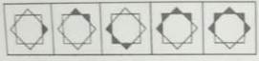
133. 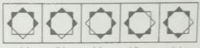
134. 
135. 
136. 
137. 

Answer Keys

|  |  |  |  |  |  |  |  |  |  |
| --- | --- | --- | --- | --- | --- | --- | --- | --- | --- |
| 1(c) | 2 (a) | 3 (e) | 4 (b) | 5 (d) | 6 (b) | 7 (b) | 8 (c) | 9 (b) | 10 (a) |
| 11 (b) | 12 (c) | 13 (b) | 14 (c) | 15 (c) | 16 (c) | 17 (d) | 18 (e) | 19 (b) | 20 (d) |
| 21 (b) | 22 (e) | 23 (d) | 24 (b) | 25 (c) | 26 (c) | 27 (c) | 28 (a) | 29 (b) | 30 (e) |
| 31 (a) | 32 (e) | 33 (b) | 34 (d) | 35 (a) | 36 (c) | 37 (c) | 38 (e) | 39 (b) | 40 (c) |
| 41 (d) | 42 (c) | 43 (c) | 44 (b) | 45 (e) | 46 (b) | 47 (e) | 48 (e) | 49 (b) | 50 (d) |