**Officer Intelligence Rating - 1**

1. **Direction**: Groups of four words are given. In each group, one word is correctly spelt. Find **the correctly spelt** word and mark your answer in the Answer-Sheet.
2. Privilege
3. Previlege
4. Prevelege
5. Privelage
6. Which of these words completes the sentence in the way that makes most sense?

“A spirit-level should be used to ensure that the surface is ______

1. Straight
2. Flat
3. Horizontal
4. Parallel
5. **Direction:** Out of four alternative, choose the word opposite in meaning and indicate you correct answer.

**LAVISH**

1. Profligate
2. Frugal
3. Factitious
4. Fecund
5. **Direction:** Read the following passage carefully and answer the questions given below.

“Light is made up of electromagnetic waves. These vary in length and it is these differences that we perceive as different colours. White light has all the wavelengths of the light spectrum mixed up together. An object looks coloured because light falls on it and it reflects only certain parts of the spectrum. The rest of the spectrum is absorbed by the object. An object that looks white reflects all the light that falls on it. An object that looks red reflects the red part of the spectrum and absorbs the rest. Our eyes detect these different reflected waves and we see them as different colours.

1. Without colours we would consider the world a dull and less beautiful place.
   1. True
   2. False
   3. Can’t say
2. White light is an amalgam of all the wave lengths of light.
3. True
4. False
5. Can’t say
6. The passage states that an object that looks blue absorbs all but the blue wavelengths of light.
7. True
8. False
9. Can’t say
10. The colour we perceive an object to be is determined by the electro-magnetic waves that it absorbs or reflects.
11. True
12. False
13. Can’t say
14. White paint reflects more light than red paint.
15. True
16. False
17. Can’t say
18. **Direction**: Groups of four words are given. In each group, one word is correctly spelt. Find **the correctly spelt** word and mark your answer in the Answer-Sheet.
19. Disentry
20. Dysentery
21. Diesentry
22. Dysentry
23. **Direction:** Out of four alternatives, choose the one which best expresses the meaning of the given and mark it in the Answer Sheet.

**PERPETUAL**

1. Constant
2. Real
3. Mistaken
4. Agreement

1. If PALE is coded as 2134, EARTH is coded as 41590, how can is PEARL be coded in that language?
2. 25430
3. 29530
4. 25413
5. 24153
6. Which of these words completes the sentence in the way that makes most sense?

“Although the two sisters are twins, they look somewhat ______.

1. alike
2. unique
3. similar
4. different
5. DRAMA is related to DIRECTOR as MAGAZINE is to
6. Printer
7. Publisher
8. Editor
9. Reader
10. In a certain 3456 is coded as ROPE and 5526 is coded as APPLE. How is 54613 written in the same code?
11. RPPEO
12. ROPEA
13. POEAR
14. PAREO
15. **Direction**: Read the following passage and answer the following questions that follows

“Asia is the world’s largest continent and stretches from the Baring Sea in the east to Turkey and Europe in the west. Its southern border comprises many islands, including those that make up Indonesia. Since independence of colonial powers Asian economies have boomed. First were Japan, Singapore, Taiwan and South Korea and later Malaysia, Thailand and Indonesia. More recently China and India have enjoyed rapid economic growth. The south-west and central parts of the continent are deserts. The Himalayan Mountains divide the cold north from the tropical south. The people of Asia make up over two-thirds of the world’s population and they live in the birthplace of the world’s earliest civilizations.”

1. Civilization began in the continent of Asia.
   1. True
   2. False
   3. Can’t say
2. The colonial era was a disaster for Asia.
3. True
4. False
5. Can’t say
6. More of the world’s population lives in Asia than in any other continent.
7. True
8. False
9. Can’t say

1. Post-colonial growth first occurred in Singapore.
2. True
3. False
4. Can’t say
5. SOLDIER is related to REGIMENT as COIL is to
6. Bearing
7. Shaft
8. Motor
9. Wheels
10. Babita runs 8 km to the South. Then she turns to her right and walks 4 km. Then again, she turns to her right and runs 8 km forward. How far is she from the starting point?
11. 8 km
12. 6 km
13. 4 km
14. 12 km
15. ______ : segue :: throng : mass
16. Subway
17. Church
18. Transition
19. Line
20. Kabul is located 2 km away to the north-west Punjab. Rohtak is located 2 km in the south-west direction from Kabul. Melghat is another place and is located 2 km away in the north-west of Rohtak. Talu is located 2 km away in the south-west direction from Melghat. In which direction is Talu from Punjab?
21. West
22. North-East
23. North-West
24. South
25. poetry : rhyme ::philosophy : ______
26. imagery
27. music
28. bi-law
29. theory
30. A
31. A
32. A

**Directions:** Select a suitable figure from the Answer Figures that would replace the question mark (?).

1. Problem Figures

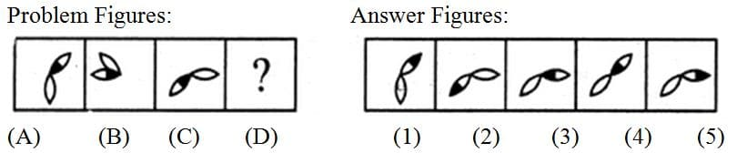

Answer Figures



1. Problem Figures

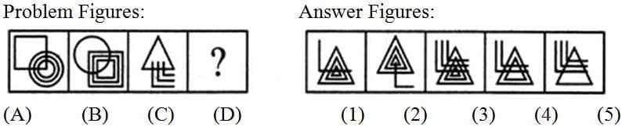

Answer Figures



A B C D

1. Problem Figures

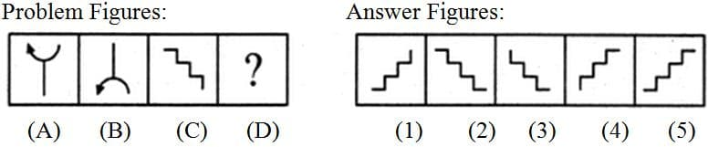

Answer Figures



A. B. C. D.

1. Problem Figures

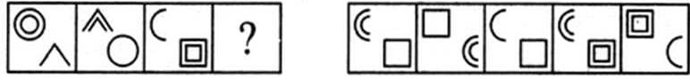

Answer Figures



A. B. C. D.

1. Which of the following diagrams indicates the best relation between Travelers, Train and Bus?
2. https://www.indiabix.com/_files/images/verbal-reasoning/venn-diagram/4-19-1-c6.png
3. https://www.indiabix.com/_files/images/verbal-reasoning/venn-diagram/4-19-1-c3.png
4. https://www.indiabix.com/_files/images/verbal-reasoning/venn-diagram/4-19-1-c9.png
5. https://www.indiabix.com/_files/images/verbal-reasoning/venn-diagram/4-19-1-c11.png
6. In the following figure triangle represents 'girls', square players and circle-coach. Which part of the diagram represents the girls who are player but not coach?

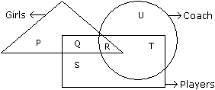

1. P
2. Q
3. R
4. S
5. A
6. A
7. A
8. A
9. A
10. A
11. A
12. A
13. A
14. A
15. A
16. A
17. A
18. A
19. A
20. A
21. A
22. A
23. A
24. A
25. A
26. A
27. A
28. a

A

a

ANSWERS

|  |  |  |  |  |  |  |  |  |  |
| --- | --- | --- | --- | --- | --- | --- | --- | --- | --- |
| 1. **D** | 1. **C** | 1. **A** | 1. **E** | 1. **A** | 1. **A** | 1. **B** | 1. **E** | 1. **D** | 1. **B** |
| 1. **C** | 1. **B** | 1. **A** | 1. **C** | 1. **A** | 1. **B** | 1. **A** | 1. **A** | 1. **C** | 1. **B** |
| 1. **D** | 1. **C** | 1. **A** | 1. **D** | 1. **B** | 1. **B** | 1. **D** | 1. **C** | 1. **C** | 1. **D** |
| 1. **B** | 1. **C** | 1. **C** | 1. **D** | 1. **D** | 1. **D** | 1. **A** | 1. **B** | 1. **A** | 1. **C** |
| 1. **D** | 1. **B** | 1. **C** | 1. **C** | 1. **B** | 1. **B** | 1. **B** | 1. **A** | 1. **D** | 1. **C** |